Background. (1) I have always been annoyed by papers from Svalbard ecologists in which they speculate about global change and uncritically accept the hypothesis of a gallo invasion on their archipelago. As a reviewer, I suggested that they soften this claim, but no one listened to me. (2) Last summer, I was on Kildin Island, conducting my usual observations on Lake Mogilnoe. My colleague asked me to collect mussels from the sea littoral, and I collected them at the most easily accessible place. The mussels confused me; they looked unusual, although I couldn't quite put my finger on what was wrong with them. I suggested to Margarita Khalitova, a student who was with me, that she test the hypothesis that this was a gallo invasion. She took the suggestion seriously, and we wrote a report on the results of the exercise, which included data from the rest of the historical GA sample stored in our collections, as well as some data produced by you at my request ten years ago. I realize that these are very simple data and a rather naive text, but perhaps they will be of some use to researchers of Arctic mussels. If you'd like, you are welcome to join as a co-author. In any case, we would be grateful for your comments.
What stands behind the alleged invasion of the Mediterranean mussel Mytilus galloprovincialis Lamarck into the Arctic — an invasion of the species, an invasion of hybrids, or an invasion of genes?
Controversy over the alleged invasion of the Mediterranean mussel Mytilus galloprovincialis Lamarck into the Arctic
Notes on the invasion of “gallarctic mussels” (hybrids between Mytilus galloprovincialis Lamarck and boreal mussels) in the Arctic.
The alleged invasion of the Mediterranean mussel Mytilus galloprovincialis Lamarck into the European subarctic and Arctic may actually be an invasion of its hybrids (gallarctic mussels)

Hybrids of Mytilus galloprovincialis Lamarck and boreal mussels (gallarctic mussels) are spreading across the Arctic
It is not the Mediterranean mussel Mytilus galloprovincialis Lamarck spreading across the Arctic, but its "gallarctic" hybrids with boreal mussels.
Abstract
The Mediterranean mussel Mytilus galloprovincialis (MG) is one of the most invasive species in the Ocean. In recent years, a hypothesis has gained traction that this temperate species has invaded the European subarctic and Arctic, reaching as far as Spitsbergen. However, this hypothesis is based solely on genetic data, which allows for alternative interpretations.
Here we first review the published data to establish where, when and with which methods mussels with MG genes have been recorded in the Arctic. We concur with authors who interpret 'Arctic MG' as resulting from admixture between MG and boreal mussels, primarily M. edulis. In Norway, the MG genetic contribution does not exceed 40% in population samples, and 65% in individual genomes. In Svalbard, these values are even smaller, whereas other areas remains poorly studied.
Second, we use genotyping at 14 taxonomically informative loci to illustrate the hybrid nature of mussels with MG genes in Norway and to check their presence in the Russian sector of the Barents Sea. In Russia, MG genetic contribution reaches 7% in population samples and 35% in individual genomes.
Third, we conduct a morphometric analysis of shells from genotyped mussels and demonstrate that mussels with an elevated MG contribution (such as those found in Norway) do show similarity to MG references. This indicates that we are indeed dealing with the invasion of a distinct taxon but not with neutral introgression. This hybrid taxon cannot formally be called MG, yet it deserves a name. We propose the label 'gallarctic mussels'.
Не больше 250 слов
https://onlinelibrary.wiley.com/page/journal/13652699/homepage/forauthors.html#manuscriptcategories
A typical Research Article is likely to be composed of the title page (title, structured abstract [≤300 words), and other front material), 5–7 pages of text (should not exceed 6,000 words), 2-3 pages of illustrative material (up to ~6 tables and figures, including captions), and 2-3 pages of references (~35 references per page) and other required statements (Conflict of Interest, Data Availability, Author Contributions).
Structured abstracts. Abstracts should be no more than 300 words, presented as a series of factual statements under the following headings: Aim, Location, Taxon, Methods, Results and Main conclusions. The Aim should give a clear statement of the principal research question(s) or hypotheses, the Taxon indicate the main group (e.g., angiosperms), the Methods should give details of materials/sampling/methods of analysis, and the Main conclusions should give the main take-home message.
Aim. The Mediterranean mussel Mytilus galloprovincialis (MG), among the most invasive species in the ocean, is warm-adapted relative to its boreal congeners; nevertheless, a hypothesis has recently gained traction that it has invaded the European subarctic and Arctic, reaching Spitsbergen. This hypothesis, however, rests solely on genetic data open to alternative interpretations. Herein, we critically examine this putative invasion.
Location. European Arctic
Taxon. Blue mussels, Mytilus edilus species complex (Bivalvia, Mytilidae)
Methods. Literature review to establish where, when, and by which methods mussels carrying MG genes have been recorded in the European Arctic. Genotyping at 14 taxonomically informative loci of samples from Norwegian and neighboring Russian populations suspected to harbor MG-like mussels, to determine whether these mussels are purebreds or hybrids. Morphometric analysis of shells from genotyped mussels to assess whether they resemble MG references.
Results. According to our data and the literature, the MG genetic contribution in Norway approaches 40% in population samples and 65% in individual genomes, whereas in Russia the corresponding values are 7% and 35%, respectively, apparently having risen in recent decades. The situation in Spitsbergen is reportedly similar to that in Russia, while most other Arctic areas remain poorly studied. Morphologically, Norwegian mussels with an elevated MG contribution do resemble MG references.
Conclusions. We concur with authors who interpret 'Arctic MG' as resulting from admixture between MG and boreal mussels, primarily M. edulis. Their morphological similarity to MG indicates that we are dealing with the invasion of a distinct taxon rather than with neutral introgression. This hybrid taxon — which supposedly inherited cold adaptations from boreal mussels and, we fear, may have inherited invasive superpowers from MG — cannot formally be called MG, yet it deserves a name. We propose the label 'gallarctic mussels'.
Introduction
Arctic marine ecosystems are undergoing profound global changes – warming, retreating sea ice, and an intensifying inflow of Atlantic and Pacific waters (Fauchald et al., 2026) – that are facilitating invasions by more warm-water-adapted species (Husson et al., 2024). One such successful colonizer of the Arctic is considered to be the Mediterranean mussel M. galloprovincialis (MG), which is generally known as one of the most harmful invasive species in the ocean (Lowe et al., 2000; ISSG 2026). MG is listed among the nonindigenous species established in the Arctic (i.e., recorded in multiple samples) up to 2015 in the widely cited review by Chan et al. (2018) as well as in more recent such inventories (e.g. CAFF/PAME 2025). Its presence alongside boreal congeners along the Norwegian coast and on Spitsbergen is regarded as an established fact in recent ecological studies (e.g., van den Heuvel‑Greve et al., 2021; Olenin et al., 2024; Pashaei et al., 2024; Strohmeier et al., 2024). This claimed invasion is puzzling because MG is a relatively thermophilic species (Somero 2012). Can it really be that the same species persists, for instance, near Kagoshima in the East China Sea at 31°N (Iwasaki et al., 2004), where average monthly sea surface temperatures (SST) range from 17 to 29 °C, and simultaneously near Longyearbyen in Spitsbergen at 78°N (Olenin et al., 2024), where SST ranges from −0.5 to 5.5 °C (SST data from https://seatemperature.info)? Such latitudinal and temperature ranges seem excessively broad for marine invertebrates and fish (see Bates et al. 2013 for a review). Here, we critically examine this putative invasion from both theoretical and empirical perspectives.
Native to the Mediterranean and Black Seas, as well as neighboring areas of the northeastern Atlantic, MG has become established over the past century in many areas of Eastern Asia, California, South Africa, Australia, New Zealand, and along both coasts of southern South America (Gosling 2021 and references therein – уточнить ссылку и время инвазии в Бразилию). The principal vectors of introduction are transport via vessel ballast water, hull fouling, and escape from aquaculture operations (Birski et al. 2012; Crego-Prieto et al. 2015; Lee, Chown 2007; уточнить REF). Almost without exception, the ecoregions where the species occurs are classified as temperate or warm-temperate (Spalding et al., 2007).
Across its invasive range, MG outcompetes native mussels, including other members of the M. edulis species complex (Carlton et al. 1999; Shinen, Morgan 2009; Assis et al. 2015), which are often collectively termed "blue mussels". In addition to MG, this complex includes several Southern Hemisphere species and two boreal taxa, M. edulis (ME) and M. trossulus (MT) (McDonald et al. 1991; Oyarzún et al., 2025). In sympatry, MG, MT, and ME usually interbreed. This gives rise to hybrid zones in which purebreds of the species coexist with admixed individuals (interspecies hybrids), typically within the same populations. In rare instances, however, admixed populations consisting entirely of hybrids arise (Bierne et al. 2003; Vainola, Strelkov 2011; Simon et al. 2020). Individuals from such populations are particularly difficult to classify taxonomically under binomial nomenclature. It should be noted that 'admixed individuals' and 'hybrids' are used here as synonyms and denote any specimens with a significant (arbitrary, >5%) contribution of genes from different species (cf. Allendorf et al. 2001). This category excludes individuals with only slight introgression of alien genes and is not restricted to early-generation hybrids, i.e., first- (F1) and second (F2) generation hybrids, and first-generation backcrosses (BC).
The blue mussel species are cryptic, lacking diagnostic morphological characters (Gosling 2021 and references therein). Among MG, ME, and MT, MG is the most distinctive, with a taller shell and beak‑like anterior end. Morphometric and multivariate analyses thus identify MG reliably in allopatry, but only probabilistically in sympatry, where hybrids especially confound discrimination (Seed et al. 1992). That is why genotyping, rather than morphology, is routinely used to identify mussel species. Historically, semi-diagnostic allozymes were used first, while afterwards diagnostic PCR-based markers were employed, of which the most popular has been the nuclear marker ME15/16 (syn. glu-5; Inoue et al., 1995), for which allopatric populations of ME, MT, and MG are fixed for different alleles (Gosling, 2021). Recently, sets of taxonomically informative single nucleotide polymorphisms (SNPs), combined with advanced multilocus genotype assignment methods, have been increasingly used to identify blue mussel species and their hybrids (e.g., Larraín et al., 2017; Simon et al., 2019; Nascimento-Schulze et al., 2023).
MG, ME and MT have been the focus of numerous comparative physiological studies, whose findings support MG as a warm-adapted species, whereas ME and MT are cold-adapted (reviewed in Somero, 2012). Admittedly, most of these studies have focused on heat tolerance rather than cold tolerance (Boroda et al., 2020). The thermal tolerance window accepted for MG, 10–32 °C (Somero, 2012), overlaps poorly with the SST across the Arctic (Wang, Wang 2020; see also the Spitzbergen example above).
Within its invasive range in the North Pacific, MG extends northward to approximately 45°N in the West (Brannock, Wethey & Hilbish, 2009), and to approximately 41°N in the East (Hilbish et al., 2010), beyond which it is replaced by the native MT. Along the Atlantic coasts of Europe, MG was, until the early 2010s, believed to extend northward as far as the north of British Isles (60°N), typically within hybrid zones with ME. More northerly—subarctic and Arctic—areas were thought to be inhabited exclusively by ME and MT (REF?, Kijewski et al., 2011; Väinölä & Strelkov, 2011). At the same time, the long coastline of Norway was poorly surveyed in that studies and Svalbard had not been studied at all, since mussels had not been recorded there until recently (Berge et al., 2005). In this context, it is noteworthy that detailed monitoring studies conducted in the British Isles have revealed no increase in the relative abundance of MG and its hybrids from the 1980s through the 2010s (Lynch et al. 2020; Diz, Skibinski 2024). Moreover, ecological niche modeling using abiotic habitat characteristics within the species' range does not forecast MG expansion in Europe beyond the North Sea by 2050 under the worst-case climate change RCP 8.5 scenario (Torres et al. 2025).
To sum up, the appearance of MG in the European Arctic—circumscribed herein according to the Arctic Large Marine Ecosystems (PAME 2013, Fig.1), including zones habitually referred to as subarctic (Dunbar 1953)—was not predicted by prior evidence. The invasion is supported exclusively by genetic studies, chiefly Brooks and Farmen (2013) and Mathiesen et al. (2017), which are cited by all adherents of the hypothesis (see references above).
Figure 1. Map of genetic studies of Mytilus mussels in the European Arctic performed using ME15/16 and/or SNP arrays relevant for the identification of M. galloprovincialis. (A) Northern Europe. The grey dashed line indicates the marine boundary of the European Arctic according to PAME (2013). (B) The area of Kildin Island in the Barents Sea. Pins with abbreviated names indicate our sampling sites, while those with numbers indicate sites from published studies. Pie charts show the frequencies of M. galloprovincialis genes (black sector) and M. edulis and M. trossulus (white sector) based on ME 15/16 in the samples. Literature data: sites 1–? from ??, … (for more details, see Table S1).
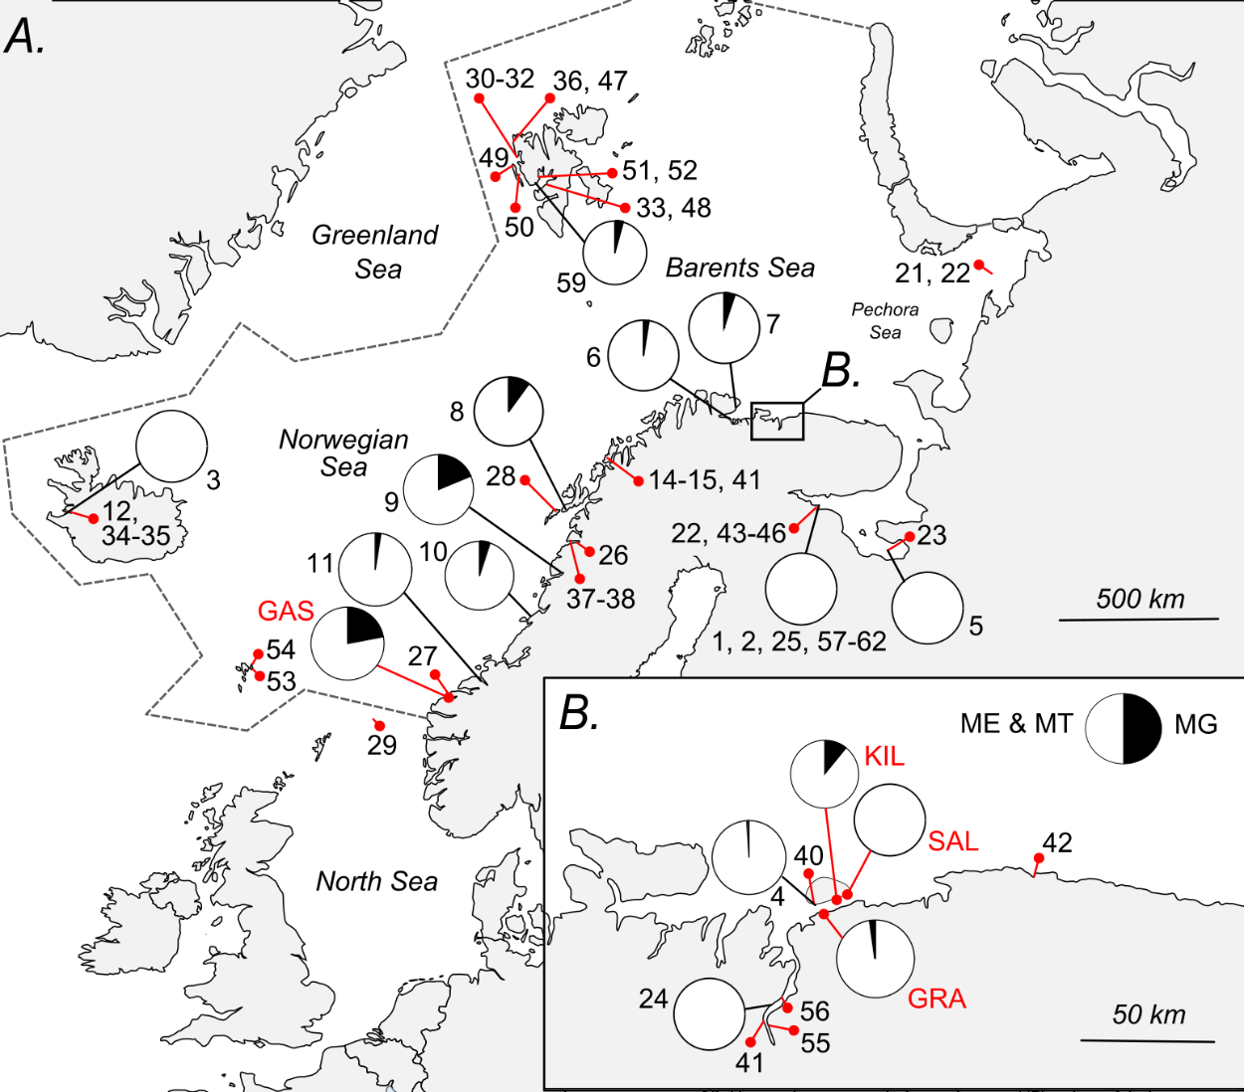

Brooks & Farmen (2013) were the first to conduct a detailed geographic survey of Norwegian mussels using the ME15/16 marker, detecting MG alleles (both homozygous and heterozygous) in many samples. They interpreted homozygotes as purebred MG and heterozygotes as its hybrids (Brooks, Farmen 2013, Fig. 1). This assumption, however, may not hold, because if species are engaged in introgressive hybridization—as blue mussel species usually are—hybrids may effectively mimic purebreds at individual loci. For instance, assuming that F1 hybrids are heterozygous for the MG allele, the expected frequencies in the F2 generation would be 1/2 heterozygotes and 1/4 homozygotes for that allele. Similarly, backcrosses and advanced-generation hybrids may display various genotypes, including homozygotes for both MG and alternative alleles. For a more confident judgment on ancestry, more markers are needed.
In their pioneering SNP study, Mathiesen et al. (2017) analyzed 12 samples from across the European Arctic using 81 random polymorphic markers (i.e., markers that were not specifically selected as taxonomically informative). Mussels with MG ancestry were found almost everywhere—from Iceland in the west to the Pechora Sea in the east, and from Norway in the south to Spitsbergen in the north. The highest frequencies were observed in the latter two regions (up to 85% in the Lofoten Islands of northern Norway), where many individuals were interpreted as pure MG. This conclusion, although entirely in line with that of Brooks and Farmen (2013), was nonetheless disputed in subsequent studies. The same samples from Mathiesen et al. (2017) from Lofoten and Spitsbergen were re-analyzed by Simon et al. (2020) using a set of 77 taxonomically informative SNPs. Surprisingly, the results differed: although mussels with MG ancestry were indeed present, none were classified as purebreds—all were hybrids. In addition to the Lofoten sample, these same hybrids dominated an additional sample from Gåseid in western Norway, which was included in the analysis (Simon et al., 2020). Concurrently, Kotwicki et al. (2021) reached conclusions consistent with those of Simon et al. (2020) regarding the absence of pure MG and the presence of only hybrids at Spitsbergen. In their survey on distribution and taxonomy of mussels across the archipelago, they genotyped numerous samples using a custom SNP set that partially overlapped with that of Mathiesen et al. (2017).
To sum up, the opinion about the presence of MG in the Arctic is based on the indisputable fact of the presence of its hybrids there, on controversial facts from early studies about the presence of purebreds as well, and — implicitly — on the assumption that the occurrence of hybrids in samples implies the local presence of parental taxa. Simon et al. (2020), however, suggested that these hybrids may represent a self-sustaining hybrid lineage between MG and ME. This hypothesis is appealing also because it obviates the need to explain the occurrence of an ostensibly warm-adapted species at high latitudes: hybrids need not inherit the phenotypes of their parental taxa. Instead, they can exhibit mixed or novel traits (Seehausen 2004; Tobler, Carson 2010; Pereira et al. 2014). Hereafter, for simplicity, we will refer to Arctic mussels with MG alleles and unresolved species identity as 'gallarctic mussels'.
The impetus for this study—namely, to clarify the genetic and taxonomic identity of gallarctic mussels and their geographic distribution—stemmed from observations made in 2025 on Kildin Island in the Russian sector of the Barents Sea (co-ordinates 69°N, 34°E, Fig. 1), a region that had hitherto not been the focus of targeted research on MG. There, some mussels in a small random sample collected for ecological monitoring struck us as unusual, bearing some resemblance to MG in their shells, most notably in their strongly skewed anterior end and great valve thickness.
We first review the published literature to determine where, when, and by what methods gallarctic mussels have been recorded in the European sector of the Arctic. Second, we genotype mussels from the Norwegian Gåseide population (known from Simon et al. 2020 to harbor a high frequency of MG alleles) at 14 taxonomically informative loci to test, using standard genotypic assignment techniques, whether they are hybrids or purebred MG. Third, we are using the same approach to search for gallarctic mussels in samples from the Kildin Island area, including both the 2025 sample and earlier collections. Finally, we perform a morphometric analysis of shells from genotyped mussels, together with reference MG specimens, to assess whether gallarctic mussels exhibit morphological affinity to the reference.
1820 слов
Materials and Methods
Mussel sampling and genotyping
Five randomly collected samples were studied (Fig. 1). (1) Sample KIL from Kildin Strait, Murman Coast, Barents Sea (N = 23, shell length range 15.9-55.6 mm, coordinates 69°19′22.5″ N, 34°19′43.3″ E, collected in 2025). This sample included mussels that we considered to resemble MG (see Introduction). (2, 3) Samples GRA (N = 52, 19.1-42.1 mm, 69°16'20.7"N 33°49'36.9"E, 2019) and SAL (N = 23, shells unavailable, 69°19'02.8"N, 34°20'51.9"E, 2015) are earlier collections from the same area, collected at a distance of about 2 km and 25 km by Sea from KIL, respectively. These samples were included to assess spatial and temporal stability in the genetic composition of local mussels. (4) Sample GAS from Gåseide, Ålesund, Norwegian Sea (N = 50, 22.1-43.2 mm, 62°27'50.4"N 6°14'29.9"E, 2015) was an unexplored part of the same sample (with the same name) studied in Simon et al. 2020. GAS serves as a reference for Norwegian gallarctic mussels. (5) Sample QIN from Qingdao, the Yellow Sea (N=10, coordinates unavailable, 2007) represented a reference of pure MG from its invasive range in Asia.
DNA was isolated from foot tissue fixed in 70% ethanol using the CTAB method (Hoarau et al., 2002). Genotyping was performed using 14 taxonomically informative nuclear markers: the Me15/16, which discriminates among all three species, and 13 biallelic SNPs developed by Simon et al. (2019). Of these, five (C96364_p474, abyss_C783_p54, abyss_C906_p35, C10081_p1314, C63342_p1271) discriminate MG from ME and MT, four (RL04_newbler, C17324_p1089, C6321_p1094, C40145_p294) discriminate ME from MT and MG, and four (gi37650308, C_27467_p175, gi_387154, gi_223020458) discriminate MT from MG and ME. Genotyping with the Me15/16 followed Inoue et al. (1995), while SNP genotyping was performed using the KASP™ array method (Semagn et al., 2014).
Population genetic analyses
For each sample, allele frequencies and observed (Ho) and expected (He) heterozygosities were calculated. Deviations from Hardy–Weinberg equilibrium and two-locus genotypic equilibrium were assessed in Genepop 4.8.6 (Rousset 2008) with default parameters. Multiple-testing correction was applied per population using the false discovery rate of Benjamini and Hochberg (1995).
Genotypic assignment
Assignment was performed using the Bayesian model-based method implemented in STRUCTURE (Pritchard et al., 2000), which probabilistically assigns individuals to a predefined number (K) of genetic clusters—representing hypothetical populations or species—and estimates individual genomic admixture proportions (Q). We a priori assumed K = 3, corresponding to ME, MT, and MG, but also ran analyses with K ranging from 2 to 10 to test alternative grouping scenarios. The best-fit number of clusters was determined using the Evanno method (Evanno et al., 2005) with the pophelper R package (Francis, 2017). For each K, STRUCTURE analyses were run ten times, using default settings, a burn‑in period of 50,000 iterations, followed by 100,000 Markov chain Monte Carlo (MCMC) iterations. Since all results reported in this study were identical across independent runs, we did not select a "best" run or combine runs.
Hybridization analysis
Individuals with Q ≥ 0.95 for any cluster in STRUCTURE were preliminary classified as pure; otherwise they were treated as admixed. A detailed hybridization analysis was conducted using PopCluster (Wang, 2025), which assigns individuals to clusters (similar to STRUCTURE but with different algorithms) and probabilistically classifies genotypes into purebreds and all possible early‑generation hybrids. The PopCluster was run using default settings. With K = 3, the analysis yields genotype assignment probabilities across 12 distinct classes: three purebred (ME, MT, MG), three F1 hybrid (ME×MT, ME×MG, MT×MG), three F2 hybrid, three BC, and three “trihybrid” categories characterized by ancestral genomic contributions of 25%, 25%, and 50%. For illustrative purposes, we also classified hybrids into four groups: all hybrids between ME and MT, all hybrids between ME and MG, all hybrids between MT and MG, and trihybrids. Importantly, PopCluster assignments should not be taken as exhaustive proof of ancestry. As with the ME15/16 example (see Introduction), classification into any given category is based exclusively on the markers employed and could change if additional markers are included or if advanced‑generation hybrids are considered. Nevertheless, we assume that if our marker set (including six MG‑diagnostic loci) assigns a genotype to pure MG with negligible probability, this genotype can be reasonably considered non‑purebred.
Analyses of modified datasets
In an attempt to determine the genetic archetype of the gallarctic mussels, we also performed analyses on modified datasets. (1) STRUCTURE analysis (K=3) of a dataset from which the QIN genotypes had been excluded. The aim was to assess whether gallarctic mussels would form a separate cluster when MG references were absent. (2) Ten STRUCTURE runs (K=3) were carried out on a dataset where the GAS genotypes were substituted with simulated genotypes from an equilibrium population (i.e., random allele associations) with allele frequencies identical to those in GAS. These simulants accordingly exhibited equal expected ancestry proportions, enabling evaluation of the variability of Q‑values among empirical GAS genotypes relative to that expected in a "true" equilibrium hybrid population. (3) Tests for genetic equilibrium and STRUCTURE analysis (K=3) of a dataset from which mussels with minor MG ancestry (Q<0.05) in a GAS sample had been excluded. The aim was to obtain a maximally pure sample of Norwegian gallarctic mussels.
Morphometric analyses.
Morphological analysis was performed on samples KIL, GRA, GAS and QIN, as no shells were available from Salma. We used two complementary approaches: outline shape analysis and classical (linear) morphometrics. Statistical analyses were run using R 4.0.5 (), and results were visualised using the package ggplot2().
Elliptical Fourier Analysis (EFA, Kuhl and Giardina, 1982) was employed to summarize the shape of each shell outline as a series of harmonic components, thereby reducing complex shell contours to a small set of quantitative coefficients. The right valves of dry mussel shells were placed on a horizontal surface with the inner (concave) side facing up, photographed, and digitized in ImageJ using the umbo as a fixed starting point, yielding 60 pairs of x, y coordinates per outline (Fig. SN). Coordinates were processed using the Momocs package (Bonhomme et al., 2014), and outlines were aligned and normalized for size, position, and starting point following Ferson et al. (1985) and Innes & Bates (1999). Coordinates were imported into R and compiled into an Out object using the Momocs package (Bonhomme et al., 2014), and outlines were aligned and normalized for size, position, and starting point, following Ferson et al. (1985) and Innes & Bates (1999). Fourier coefficients were extracted using the efourier() function, with the number of harmonics selected based on harmonic power calibration. The resulting coefficients were subjected to Principal Component Analysis (PCA) to summarize shape variation among specimens. The first two principal components, hereafter referred to as PC1_{outline} and PC2_{outline}, were treated as composite shape indices. Scores were regressed on mussel Qmg across the full dataset, within Arctic samples, and within GAS separately, using linear regression with permutation-based Pearson correlations (coin package; Hothorn et al., 2006). Не нужно сравнить с Qmt и Qme - ведь все равно спросят?
Figure 2. Conchological features of gallarctic mussels. (A) Photographs of selected mussel shells from different samples differing in shape and/or contribution of MG alleles; Qmg values are indicated below the photos. Colored shell pictograms at the top reflect the averaged shell outline of all mussels from the samples. (B) Morphospace of the first two components of the PCA of the Fourier coefficients of shell outlines. Points – individual mussels. Point colors denote samples as in A. Numbers label the shells shown in A. (C) Classical shell traits measured in this study. For verbal description of all traits but tkn (shell thickness), see McDonald et al. 1991. Traits with the highest loadings (r>0.3) on the first non-canonical component of RDA (PC1_classic) are shown in red. (D) Relationship between Qmg and PC1_classic. Boxplots (надо раскрыть) represent the samples. For GAS, primary data are also shown, points – individuals, line – linear regression, gray area – 95% confidence interval of the regression.
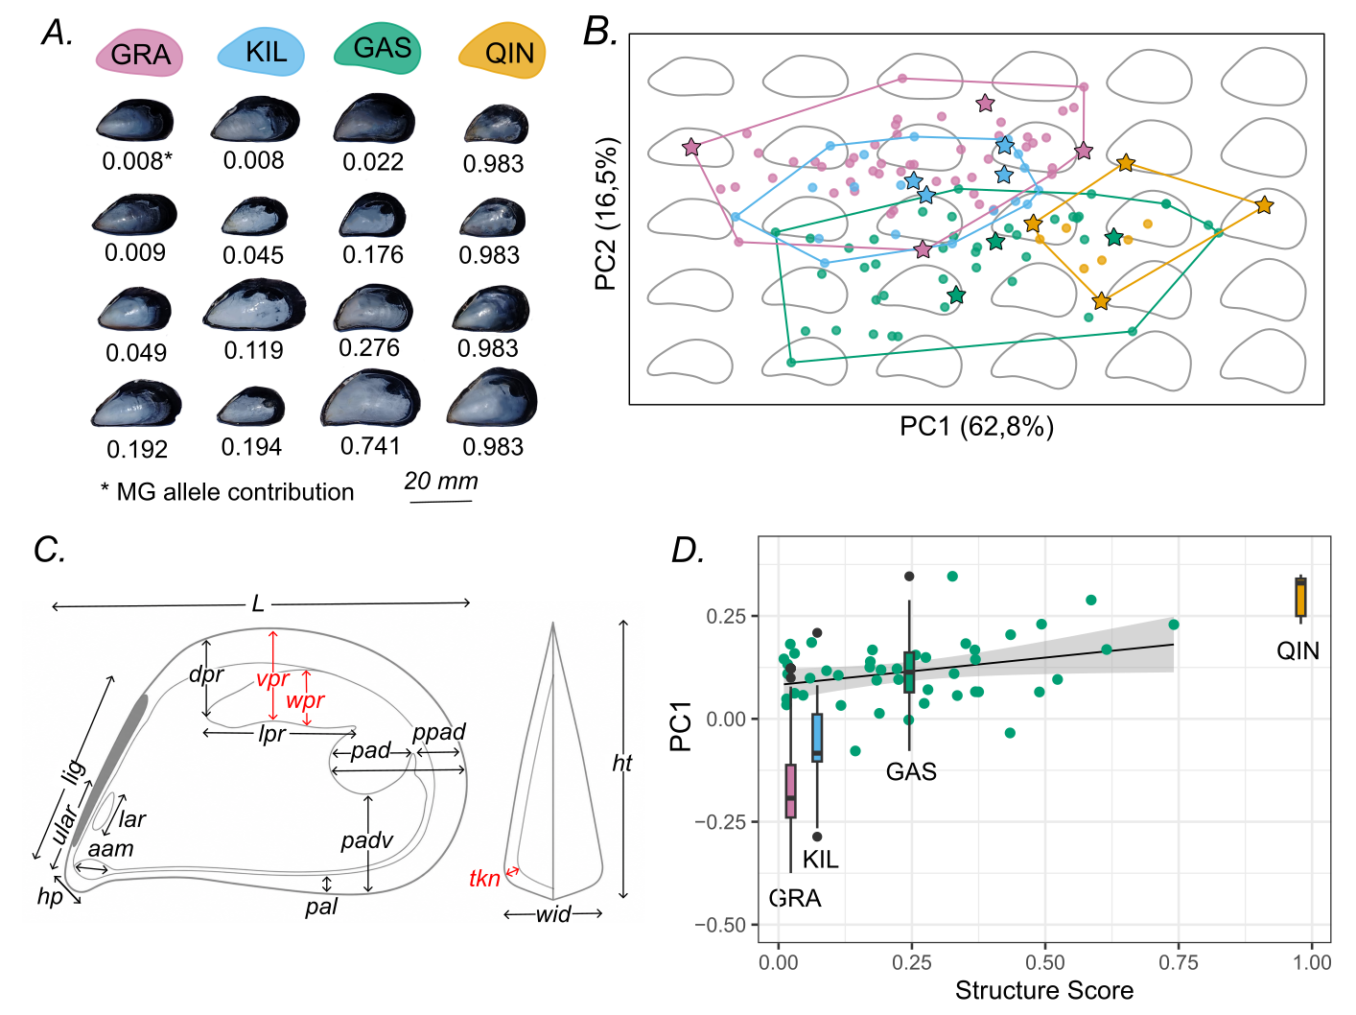
For right valve of each mussel, 16 conchological traits (Fig. 2C) were measured using digital calipers. These same traits were used by McDonald et al. (1991) in a classical study to differentiate allopatric ME, MT and MG. In addition, shell wall thickness was measured at the mid-valve with a dial gauge (Fig. 2N), since MG shells have been reported to be thicker-walled than those of ME and MT (REF). This yielded 17 traits in total. All measurements were made with precision 0.01 mm. Each trait value was log₁₀-transformed and divided by log₁₀-transformed shell length prior to statistical analysis, following common practice (e.g. McDonald et al., 1991; Gardner, 1996; Gardner and Thompson, 2004). To separate size-related from size-independent shape variation, we performed a Redundancy Analysis (RDA; Legendre & Legendre, 2012) using the rda() function in the vegan package (Oksanen et al., 2020), with shell length as the constraining variable and the remaining 16 morphological traits as the response matrix. RDA is a multivariate ordination technique combining multiple regression with principal component analysis: it partitions variation in the response variables into a component explained by the constraining predictor (the constrained, or canonical, axis) and a residual component described by unconstrained principal component axes. RDA model significance was assessed using permutation tests (9999 permutations) with the anova.cca() function. The constrained axis, representing size-related allometry, was excluded from further consideration, whereas the first two unconstrained axes (PC1_{classic} and PC2_{classic}), reflecting size-independent shape, were retained. The correlations between PCs, treated as a composite shape indices, Qmg as well as PC1_{outline} and PC2_{outline}, were evaluated as above.
Bibliographic search
To identify relevant publications, we conducted a series of Google Scholar searches combining mussel species names, genotyping methods, and the names of the Arctic regions, e.g., ("Mytilus" OR "mussel" OR "mussels") AND ("SNP" OR "genotyping" OR "marker") AND ("Barents Sea" OR "White Sea" OR "Norwegian Sea" OR "Svalbard" OR "Iceland"). Search results were screened up to the first 100 hits (Google Scholar default). The results were supplemented by screening the reference lists of the retrieved sources.
Studies were included if they reported genotyping of Mytilus spp. at nuclear markers relevant for the identification of MG. Mitochondrial data was not considered, as mtDNA is of limited utility for distinguishing MG from ME (Quesada et al. 2002). From the retrieved studies, we selected those that reported genotyping results for ME15/16, the most commonly used diagnostic marker or, in multilocus studies, that employed MG references and reported population-level or individual genetic contributions of MG (e.g., STRUCTURE Qmg). When Q-values were not reported numerically, we extracted them from STRUCTURE plots using neural-network-based image analysis: pixels were classified by color according to RGB distance to cluster reference values, and Q-values were calculated and verified manually.
The most detailed allozyme study of regional mussels (Väinölä & Strelkov, 2011), which included a sample (#26, Kildin, Mogilnaya Inlet) exactly matching the coordinates of our KIL site, employed a marker set capable of discriminating between ME, MT, and MG; however, it lacked reference samples for MG and did not test the hypothesis of its presence. To assess whether MG contributed to their dataset, we re-analyzed it (loci Est, Odh, Pgm, Gpi-2, Idh-1, Lap, Ap, and Mpi; 32 samples collected 1990-2004, N = 1356, with individuals typed at least for seven markers) using STRUCTURE (K=3, with the same settings as above), this time including simulated MG genotypes (N = 200) based on the allele frequencies in Galician MG reported by Väinölä and Hvilsom (1991).
<1800 слов
Results
Population genetic analyses
Genetic diversity was lowest in QIN (Ho = 0.01, He = 0.01), followed by SAL (Ho = 0.04, He = 0.05). GRA (Ho = 0.05, He = 0.33) and KIL (Ho = 0.19, He = 0.29) exhibited higher polymorphism, with GAS showing the highest diversity (Ho = 0.44, He = 0.41). After correction for multiple testing, significant deviations (p<0.05) from Hardy-Weinberg equilibrium were observed in GRA and KIL, and significant deviations from gametic equilibrium - in GRA, KIL, and GAS. High polymorphism and significant deviations from genetic equilibrium suggests taxonomic heterogeneity within the samples.
At the ME15/16 locus, QIN was fixed for MG alleles, whereas SAL lacked these alleles entirely. In contrast, two heterozygotes were detected in GRA (4% of the sample) and five in KIL (22%), while the GAS sample contained 14 heterozygotes (28%) and four homozygotes (8%) (Fig. 3A). Across all six loci diagnostic for MG, MG alleles were present in only a few individuals from SAL and GRA, in two-thirds of the individuals from KIL, and in nearly 90% of the individuals from GAS. The maximum number of MG alleles per individual in these four samples was three, one, two, and nine, respectively, compared to the maximum possible value of 12 observed in the QIN mussels (Fig. 3B).
The PopCluster and STRUCTURE analyses with K=3 produced virtually identical results. Below, the ancestry proportions in individual genomes attributed to MG, ME, and MT are denoted as Qmg, Qme, and Qmt, respectively. The QIN consisted exclusively of pure MG (Qmg>95%), whereas the SAL was predominantly composed of pure ME. The GRA and KIL were largely mixtures of pure ME and MT. Elevated MG ancestry (Qmg > 5%), up to 30%, occurred in occasional individuals from SAL and GRA, but in over half of the KIL individuals, with the contributions being roughly proportional to the number of MG alleles. In the GAS sample, contributions from all three species showed considerable inter‑genotype variation (Qmg 0–74%, Q_{MT} 1–55%, Q_{ME} 14–99%), and admixture from all three species was prevalent. Pure ME individuals were rare, and none were pure MT or MG (Fig. 3C). The mean Qmg values across the four samples were 3%, 2%, 7%, and 24%.
In detail, the results of the PopCluster classification into purebreds of the three species and all possible early-generation hybrids between them are given in ESM, and in simplified form – in Fig. 3D. The program found all possible hybrids between the species, including trihybrids, which were especially numerous in GAS (24% of the sample). There was not a single purebred MG: the maximum probability of assigning a genotype to this category was only 4%. Most hybrids with MG were assigned to their class with a probability of less than 90% (ESM).
Although the Evanno method determined the best-fit number of clusters in the STRUCTURE analysis as K = 3, the results with K = 4 also seemed biologically meaningful. With K = 4, most Arctic genotypes with an elevated frequency of MG alleles demonstrated affinity to a separate cluster, while the classification of the rest, including QIN, was almost the same as at K = 3 (ESM). Similar results were obtained in the STRUCTURE analysis (K = 3) from which the QIN sample had been excluded: in the absence of MG references, the gallarctic mussels formed their own cluster, on par with ME and MT (ESM).
Replacing GAS genotypes in STRUCTURE analyses with simulated equilibrium samples having the same allele frequencies produced the following result. Q‑value distributions among simulants were non‑uniform, but narrower than in empirical genotypes—by ~40% for Qme and Qmt, and ~20% for Qmg. This implies that the high genotypic variability in GAS is explained to a large extent—though not fully—by methodological noise related to the small number of loci in the analysis.
After excluding 11 genotypes from GAS with Qga < 5%, we obtained a sample close to Hardy–Weinberg and gametic equilibrium, with no significant deviations observed after correction for multiple testing. The allele frequencies of MG at the ME15/16 marker was 28%, while Qme = 51%, Qmt = 18%, and Qmg = 31%.
Figure 3. Genetic structure of the studied samples. (A) ME 15/16 genotypes. Sectors of different colors show species-specific alleles: blue – ME, red – MT, orange – MG. (B) Proportion (why not number 0–12?) of MG alleles at the six diagnostic loci (orange columns). (C) STRUCTURE plot (K=3), columns – genotypes, colored sectors – ancestry proportions from different species: blue – ME, red – MT, orange – MG. (D) Results of PopCluster classification, columns – genotypes, colors denote purebreds of different species and their hybrids (see Legend).
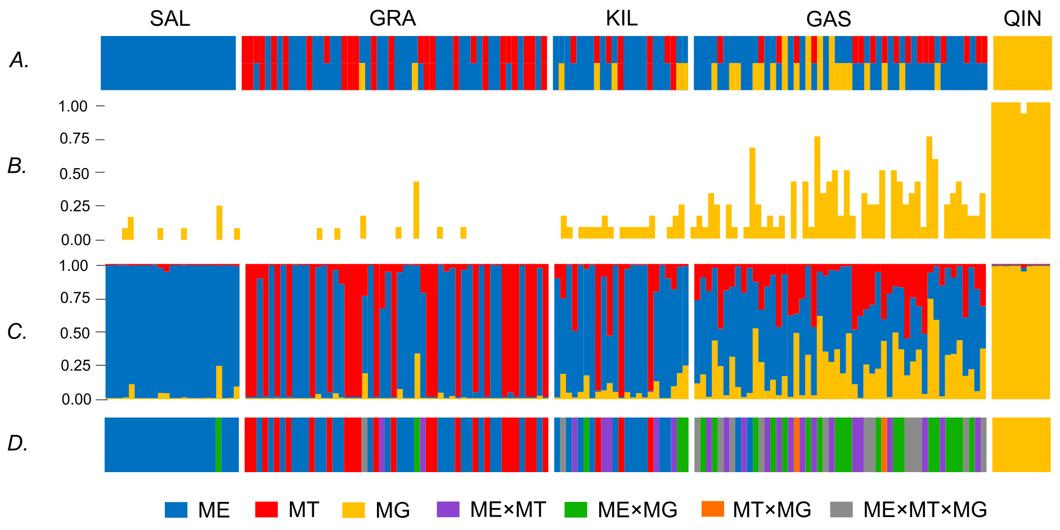
Morphological analysis
Visually, the shape of the mussel shells varied considerably within the studied samples, partially masking interpopulation differences, and in all Arctic samples, individual mussels, given sufficient imagination, could be found to resemble MG mussels from QIN in certain respects (Fig. 2A). This similarity was formally assessed using Elliptical Fourier Analysis of shell outlines (EFA). The analysis, based on seven harmonics, yielded 28 Fourier coefficients per mussel. In the PCA of these coefficients, PC1_{outline} and PC2_{outline} accounted 62.8% and 16.5% of total shape variation, respectively. PC1_{outline} was associated mainly with shell height, with high scores corresponding to taller, more triangular shells and low scores to shells that were flatter and more elongate along the antero-posterior axis. Variation along PC2_{outline} reflected the curvature of the ventral margin and the degree of pointing or down-turning ("beaking") of the anterior end. Mussels with a straight or convex ventral margin had high scores along this component, whereas those with a markedly incurved ventral margin and a beaked anterior end had low scores.
In the morphospace defined by PC1_{outline} and PC2_{outline}, mussels from KIL and GRA largely overlapped, having low PC1_{outline} and high PC2_{outline} scores, whereas those from QIN were clearly separated from them, having high PC1_{outline} and low PC2_{outline} scores. Mussels from GAS, in turn, had low PC2_{outline} scores but showed the greatest variation along PC1_{outline}, overlapping with all other samples — almost completely with GAS and partially with the remaining samples (Fig. 2B). In terms of morphology, shells from QIN were higher and more angular dorsally, with a pointed, oblique anterior end, whereas mussels from KIL and GRA possessed more elongate, lower shells, with the ventral margin either straight or distinctly convex. Mussels from GAS were either elongate or high, but an incurved ventral margin was present in most individuals (Fig. 2B). A low but statistically significant correlation was found between both PCs and Q_{mg} across the entire dataset: r = 0.38 (p = 0.0014) for PC1_{outline} and r = -0.39 (p = 0.00? - единообразно) for PC2_{outline}. However, no relationships were found between the PC scores and Q_{mg} within the Arctic samples or within GAS alone (p<<0.5).
The RDA model (shell length as constrained predictor, 16 remaining conchological traits as response matrix) was significant (F = 103.52, p = 0.0001), with the constrained axis explaining 45.10% of total trait variance. As all traits were length-standardized prior to RDA, this indicates allometric dependencies. Among unconstrained (size-independent) axes, PC1_{classic} explained 46.31% and PC2_{classic} 11.11% of residual variance. PC1_{classic} was most strongly associated (loadings r > 0.3, all positive) with tkn (shell wall thickness), wpr (width of posterior retractor muscle scar), and vpr (distance between ventral edge of posterior retractor muscle scar and dorsal shell margin). PC2_{classic} was most strongly associated with aam (length of anterior adductor muscle scar, negative association). In the space of these components, mussels from QIU — with the highest scores on both components — clustered separately from the Arctic samples, which partially overlapped with each other. Of the Arctic samples, GAS partly overlapped with QIU along the first component, while KIL and, to a lesser extent, GRA did so along the second (SFigure ?, see also Fig. 2D for differences between samples against PC1_{classic}). Both PCs showed a significant correlations with Qmg across the entire dataset: r = 0.77 (p = 0.001) for PC1_{classic}, r = 0.39 (p=0.001) for PC2_{classic}. A marginally significant correlation was also recorded between PC1_{classic} and Qmg in mussels from GAS (r = 0.31, p = 0.07, Fig. 2D) while other correlations tested were low and insignificant.
The results of both morphometric approaches, EFA and RDA were highly concordant: PC1_{classic} was strongly correlated both with PC1_{outline} (r=0.48, p=???) and with PC2 _{outline} (r=-0.61, p=???) while PC2_{classic} weakly but significantly correlated with PC1_{outline} (r=0.15, p=???). It follows that mussels with taller and more triangular shells and (or) an incurved ventral shell margin generally had thicker shells and larger (hence stronger) posterior retractors, and that this combination of traits was statistically associated with MG, with the gallarctic mussels being on average intermediate between MG and boreal species.
Bibliographic search – это напоминает общение слепого с глухим. Были пожелания: инкорпорировать данные по ме15/16 из Vainola, Strelkov 11 и внимательно посмотреть верхнюю панель в Vainola, Strelkov 11: не все «пины из ранних статей» в Норвегии, Исландии и Белом море (Varvio et al. 1988; McDonald et all., 1991) инкорпорированы в таблицу. Сверх этого я тыкаю не в того Brooks & Farmen - https://doi.org/10.1016/j.aquatox.2014.12.018 - и вижу не учтенную выборку из-под Алесуна генотипированную по ме15/16. Так был ли search? Берген кстати наша не наша территория?
- A bibliographic search yielded ? articles, из которых в ? рапортовались данные по Me 15/16, в - ? по батареям SNP и в ? allozymes, остальные – что?
- Me 15/16 data on Norwegian coast come exclusively from Brooks and Farmen (2013) and 2014? In their samples неизвестный годов сбора MG аллели встречаются повсеместно с частотой от 2 до 19% (Fig. 1, #6–11). Таким образом, наша GAS 2015 года сбора with MG allele frequency 22% - чемпион.
- Свальбард представлен единственной выборкой из ?? (?%), как и Исландия (0%). Множество (as much as) выборок из Белого моря, all but two represent populations of the same area in the NW of the sea, and all report zero MG allele frequencies.
- Последний изученный по ме15/16 район – Мурманский берег Баренцево моря, откуда наши выборки KIL, SAL и GRA – в литературе представлен аж целыми ?? выборками таких-то годов сбора, из которых только в одной маленькой (N=20) выборке 2003 г. сбора с о. Кильдин найден аллель MG с частотой 5%. (Fig.1, #4). Таким образом, наш GRA и KIL таких-то годов сбора with MG allele frequency ??% и ??%, соответственно, - опять чемпионы.
- Сопоставление results of SNP studies of Mathiesen et al. (2017) и Simon et al. (2020) по одним и тем же выборкам со Svalbard (N?-?) and Lofoten (N?) позволяет предположить, что в первой работе не только неправильно классифицировали мидий с MG аллелями на чистопородных и гибридов, но и могли завышать популяционные оценки вклада MG аллелей, в среднем на ??%. Если это так, то остальные оценки Mathiesen et al. (2017), рапортующие Qmg порядка ??% для Белого моря, (N?,), Печорского моря (N?), откуда еще? – хуйня, что косвенно подтверждается/не подтверждается Венне для Белого моря.
- Оценки Симона для Гасейд vs. наши (нужно здесь приплетать МТ?)
- Шпиц (а не Свальбард) подробно изучен - можно ли сделать вывод, что как в России?
- Последний неоднократно изученный район – Мурман vs. наши оценки.
A comparison of the results of Mathiesen et al. (2017) with the later reanalysis by Simon et al. (2020) shows that the MG allele contributions reported by Mathiesen et al. were overestimated: whereas their data indicated purebred MG individuals in Svalbard and Lofoten, with mean Qmg reaching 0.19 and 0.73, respectively, Simon et al. found mean Qmg on Svalbard to be roughly similar, but on Lofoten only about half as high, with no purebred individuals detected at all. Our finding that the Gåseid sample consists entirely of hybrids corroborates the results obtained by Simon et al. for the same locality (Fig. ##, GAS) and adds the further observation that these are “trihybrids” involving ME, MG, and MT, whereas MT was excluded from the analysis of Simon et al.
In the Barents Sea, elevated Qmg values in individual specimens have been reported at Dalnie Zelentsy (Wenne et al., 2020) and Retinskoe (Simon et al., 2021) – 0.15 and 0.18, respectively – although the mean Qmg at these sites did not exceed 0.02. Accordingly, the mussels in our samples currently show the highest MG allele contributions recorded in the Barents Sea (0.25). In the White Sea, numerous studies based on Me 15/16 (Smietanka et al., 2004; Kijewski et al., 2011; Khaitov et al., 2018; Bakhmet et al., 2022; Sokolova et al., 2024; Sukhotin et al., 2026) failed to detect MG alleles, whereas multilocus analyses (Wenne et al., 2020) occasionally revealed isolated individuals with MG contributions of up to 0.1.
Early multilocus allozyme studies by Varvio et al. (1988), McDonald et al. (1991) and Hummel et al. (2001), carried out on collections from the 1980s–1990s and including MG reference samples — taken together, quite detailed in the White and Barents Seas, but practically not covering the rest of the Norwegian coast — revealed no similarity between the studied samples and MG references evaluated either by principal component or cluster analyses, whereas individual assignment was not performed. All but one of the later allozyme studies (e.g. Ridgway & Nævdal 2004; Katolikova et al. 2016; Marchenko et al. 2023) were aimed solely at mapping ME and MT, used only a few loci, and appear uninformative for judging gallarctic mussels (see ESM? for details). One study remains — Väinölä and Strelkov (2011), based on broad collections from the 2000s, whose primary data we re-analyzed using STRUCTURE together with the simulated MG reference sample. The results showed that in the reference MG sample, Qmg varied 81–99% among simulated genotypes (mean — 99%), reflecting the not 100% diagnostic value of the marker set. The MG contribution was uniformly low in the White Sea and the Russian sector of the Barents Sea (maximum and mean Qmg values in samples not exceeding 10% and 1%, respectively), as well as in all Norwegian samples except that from Espeland near Bergen, which is already ?? km south of the Arctic border in Fig. 1. In Espeland, Qmg approached 33% with the mean 3%. The corresponding values in the sample collected in 2003 from our KIL site (#26 in SFig.?) — were 7% and 1%, i.e., approximately the same as everywhere in the Barents Sea.

References
The Global Invasive Species Database. 2026/ Available from https://www.iucngisd.org/gisd/.
Iwasaki, K., Kimura, T., Kinoshita, K., Yamaguchi, T., Nishikawa, T., Nishi, E., Yamanishi, R., Hayashi, I., Okoshi, K., Kosuge, T., Suzuki, T., Henmi, Y., Furota, T. & Mukai, H. (2004). Human-mediated introduction and dispersal of marine organisms in Japan: results of a questionnaire survey by the Committee for the Preservation of the Natural Environment, the Japanese Association of Benthology. Japanese Journal of Benthology, 59, 22–44. https://doi.org/10.5179/benthos.59.22
Li J, Yang B, Mokrani A, Xu M, Han X, Bean TP, Ellis RP, Liu S. Geographic origin and post-invasion genetic divergence of Mytilus galloprovincialis in China. Mar Pollut Bull. 2026 Jan;222(Pt 3):118807. doi: 10.1016/j.marpolbul.2025.118807. Epub 2025 Oct 14. PMID: 41092661. – про инвазию в Китае, если нужна
Bates AE, McKelvie CM, Sorte CJ, Morley SA, Jones NA, Mondon JA, Bird TJ, Quinn G. Geographical range, heat tolerance and invasion success in aquatic species. Proc Biol Sci. 2013 Dec 7;280(1772):20131958. doi: 10.1098/rspb.2013.1958. PMID: 24266040; PMCID: PMC3813329.
Crego-Prieto, V., Ardura, A., Juanes, F. et al. Aquaculture and the spread of introduced mussel genes in British Columbia. Biol Invasions 17, 2011–2026 (2015). https://doi.org/10.1007/s10530-015-0853-z
Lee JE, Chown SL (2007) Mytilus on the move: transport of an invasive bivalve to the Antarctic. Mar Ecol Prog Ser 339:307-310 https://doi.org/10.3354/meps339307
James T. Carlton, Jonathan B. Geller, Marjorie L. Reaka-Kudla, Elliott A. Norse. 1999. Historical Extinctions in the Sea. Annual Review of Ecology, Evolution, and Systematics 30:515-538. https://doi.org/10.1146/annurev.ecolsys.30.1.515
Shinen JS, Morgan SG (2009) Mechanisms of invasion resistance: competition among intertidal mussels promotes establishment of invasive species and displacement of native species. Mar Ecol Prog Ser 383:187-197 https://doi.org/10.3354/meps07982
Assis J, Zupan M, Nicastro KR, Zardi GI, McQuaid CD, Serrão EA (2015) Oceanographic Conditions Limit the Spread of a Marine Invader along Southern African Shores. PLoS ONE 10(6): e0128124. https://doi.org/10.1371/journal.pone.0128124
Oyarzún, Pablo A., et al. "Global species delimitation of smooth-shelled blue mussels in the Mytilus edulis complex." Scientific Reports (2025).
Bierne N, Borsa P, Daguin C, Jollivet D, Viard F, Bonhomme F, David P. Introgression patterns in the mosaic hybrid zone between Mytilus edulis and M. galloprovincialis. Mol Ecol. 2003 Feb;12(2):447-61. doi: 10.1046/j.1365-294x.2003.01730.x.
Allendorf, F. W., Leary, R. F., Spruell, P., & Wenburg, J. K. (2001). The problems with hybrids: setting conservation guidelines. Trends in ecology & evolution, 16(11), 613-622
McDonald, J.H., Seed, R. & Koehn, R.K. Allozymes and morphometric characters of three species of Mytilus in the Northern and Southern Hemispheres. Mar. Biol. 111, 323–333 (1991). https://doi.org/10.1007/BF01319403
James T. Carlton, Jonathan B. Geller, Marjorie L. Reaka-Kudla, Elliott A. Norse. 1999. Historical Extinctions in the Sea. Annual Review of Ecology, Evolution, and Systematics 30:515-538. https://doi.org/10.1146/annurev.ecolsys.30.1.515
Shinen JS, Morgan SG (2009) Mechanisms of invasion resistance: competition among intertidal mussels promotes establishment of invasive species and displacement of native species. Mar Ecol Prog Ser 383:187-197 https://doi.org/10.3354/meps07982
Assis J, Zupan M, Nicastro KR, Zardi GI, McQuaid CD, Serrão EA (2015) Oceanographic Conditions Limit the Spread of a Marine Invader along Southern African Shores. PLoS ONE 10(6): e0128124. https://doi.org/10.1371/journal.pone.0128124
Seed R. Systematics, evolution and distribution of mussels belonging to the genus Mytilus: an overview. Am malac Bull 1992;9:123–37.
Nascimento-Schulze JC, Bean TP, Peñaloza C, Paris JR, Whiting JR, Simon A, Fraser BA, Houston RD, Bierne N, Ellis RP. SNP discovery and genetic structure in blue mussel species using low coverage sequencing and a medium density 60 K SNP-array. Evol Appl. 2023 Apr 25;16(5):1044-1060. doi: 10.1111/eva.13552. PMID: 37216031; PMCID: PMC10197230.
Larraín, M., Zbawicka, M., Araneda, C., Gardner, J. P. A., & Wenne, R. (2017). Native and invasive taxa on the Pacific coast of South America: Impacts on aquaculture, traceability and biodiversity of blue mussels (Mytilus spp.). Evolutionary Applications, 11, 298–311. https://doi.org/10.1111/eva.12553
Torres, R., et al. (2025). Climate-induced habitat shifts of farmed mussel species. Aquaculture, 595, 741460
Diz AP, Skibinski DOF. Patterns of admixture and introgression in a mosaic Mytilus galloprovincialis and Mytilus edulis hybrid zone in SW England. Mol Ecol. 2024 Feb;33(3):e17233. doi: 10.1111/mec.17233. Epub 2023 Dec 8. PMID: 38063472.
Lynch, S.A., Coghlan, A., Leary, B.O. et al. Northward establishment of the mediterranean mussel Mytilus galloprovincialis limited by changing climate. Biol Invasions 22, 2725–2736 (2020). https://doi.org/10.1007/s10530-020-02294-6
Wang, J., & Wang, S. (2020). Sea surface temperature variability in the Arctic Ocean and its marginal seas in a changing climate: Patterns and mechanisms. Global and Planetary Change, 192, 103248.
Tobler M, Carson EW. Environmental variation, hybridization, and phenotypic diversification in Cuatro Ciénegas pupfishes. J Evol Biol. 2010 Jul;23(7):1475-89. doi: 10.1111/j.1420-9101.2010.02014.x. Epub 2010 May 26. PMID: 20524951.
Dunbar, M. J. (1953). Arctic And subarctic marine ecology: immediate problems. Arctic 6 (2), 75–90. doi: 10.14430/arctic3869
Pereira RJ, Barreto FS, Burton RS. Ecological novelty by hybridization: experimental evidence for increased thermal tolerance by transgressive segregation in Tigriopus californicus. Evolution. 2014 Jan;68(1):204-15. doi: 10.1111/evo.12254.
Seehausen O. Hybridization and adaptive radiation. Trends Ecol Evol. 2004 Apr;19(4):198-207. doi: 10.1016/j.tree.2004.01.003.
Quesada, H., Francis, D. O., Skibinski, D. A. G., Gallagher, C., & Skibinski, D. A. G. (2002). Patterns of polymorphism and gene flow of gender-associated mitochondrial DNA lineages in European mussel populations. Molecular Ecology, 11(11), 2205–2219.DOI: 10.1046/j.1365-294X.2002.01602.x
Väinölä, R., & Hvilsom, M. M. (1991). Genetic divergence and a hybrid zone between Baltic and North Sea Mytilus populations (Mytilidae: Mollusca). Biological Journal of the Linnean Society, 43(2), 127–148.
Rousset F. genepop'007: a complete re-implementation of the genepop software for Windows and Linux. Mol Ecol Resour. 2008 Jan;8(1):103-6. doi: 10.1111/j.1471-8286.2007.01931.x. PMID: 21585727.
Briski, E., Ghabooli, S., Bailey, S.A. et al. Invasion risk posed by macroinvertebrates transported in ships’ ballast tanks. Biol Invasions 14, 1843–1850 (2012). https://doi.org/10.1007/s10530-012-0194-0
Hummel, H., Colucci, F., Bogaards, R. et al. Genetic traits in the bivalve Mytilus from Europe, with an emphasis on Arctic populations. Polar Biol 24, 44–52 (2001). https://doi.org/10.1007/s003000000174

To characterize the genetic structure of our samples – это так называется?, we used two clustering programs, STRUCTURE (Pritchard et al., 2000) and PopCluster (Wang, 2025). Both assign individuals to genetic clusters based on genotype data but differ in approach. STRUCTURE uses a Bayesian, model-based method: it assumes a statistical model of allele frequencies within "pure" clusters and finds the individual assignment that best fits this model. PopCluster instead uses a likelihood-based method: it tests possible cluster assignments and selects the one that makes the observed genotypes most probable, without assuming a predefined model. The two methods generally yield similar results, but PopCluster is less sensitive to sample size and can directly classify hybrid categories, rather than only estimating overall admixture proportions.
STRUCTURE analyses were run for K values from 3 to 4, reflecting our expectation of three parental species plus potential hybrids, in order to test whether hybrids formed a genetically distinct cluster of their own. Each K was run with 10 replicates, each consisting of a burn-in period of 50,000 iterations followed by 100,000 Markov chain Monte Carlo (MCMC) iterations. The best-fit number of clusters was determined using the Evanno method (Evanno et al., 2005), implemented in the pophelper R package (Francis, 2017).
PopCluster analyses were run for K values from ? to ? using the ? method, with ? iterations of the simulated annealing algorithm per run. The optimal number of clusters was assessed using the DLK2 and FST/FIS estimators (Wang, 2025).

Hybrid classification
Individuals with an ancestry STRUCTURE coefficient q ≥ 0.9 for a single cluster were classified as pure, whereas those with intermediate values (0.1 < q < 0.9) were considered potential hybrids. PopCluster classification of hybrid categories was then used to further characterise the genetic composition of admixed individuals…
План

Цель номер 1: выяснить, что нам известно про MG в Европейской Арктике. | First, we aimed to determine where, when, and by which methods the presence of MG alleles had been recorded in the European Arctic.
Определение (границы) Европейской Арктики в нашем понимании. | Here, we define the European Arctic as the region comprising the Faroe Plateau, Iceland Shelf and Sea, Norwegian Sea, and Barents Sea Large Marine Ecosystems (LMEs) according to their boundaries established in the revised Arctic LME map (PAME, 2013) (ссылка на рисунок).
Как мы искали литературу, подходящую под наш запрос? | To identify genetic studies of mussels from the European Arctic we conducted a series of Google Scholar searches combining mussel species names, genotyping methods, and region names under consideration. Publications were first screened by title and abstract. Full texts were reviewed only for ambiguous cases, such as ecological or physiological studies. Reference lists of the selected articles were then examined to locate additional relevant studies not captured by the direct search.
Цель номер 2: проиллюстрировать гибридную природу норвежских мидий с аллелями MG и проверить их присутствие в Российском секторе Баренцева моря (подразумевается, что во Введении мы упомянули данных норвежских мидий). | Secondly, we aimed to characterise the hybrid ancestry of Norwegian mussels carrying MG alleles and to test for their presence in the Russian sector of the Barents Sea.
Для этого мы собрали genetic dataset, включающий такие-то выборки (N) оттуда-то такого-то года сбора. | For this purpose, we compiled a dataset including a previously studied sample from Gåseid, Norway (Simon et al., 2019), three samples from the Kildin Island area in the Barents Sea, and a reference sample of invasive MG from Qingdao, China (ссылка на таблицу for details).
Мидий генотипировали по таксономически информативным локусам так-то и так-то. | DNA was isolated from foot tissue fixed in 70% ethanol using the CTAB method (ссылка). Genotyping was performed with a panel of 14 nuclear loci — Me 15/16 and 13 taxonomically informative SNPs developed in (ссылка) — allowing discrimination between ME, MT, and MG. Genotyping at the Me 15/16 locus followed (Inoue et al., 1995), while SNP genotyping was performed with the KASP™ array method (ссылка).
Чтобы охарактеризовать генетическую структуру наших выборок, мы использовали две программы: Structure и PopCluster. Они похожи, но кое-чем различаются. | To characterise the genetic structure of our samples, we used two clustering programs: STRUCTURE and PopCluster. Both assign individuals to genetic clusters based on genotype data, but differ in approach.
Принцип работы программ такой. | STRUCTURE uses a Bayesian, model-based method: it assumes a statistical model of allele frequencies within "pure" clusters and finds the individual assignment that best fits this model. PopCluster instead uses a likelihood-based method: it tests possible cluster assignments and selects the one that makes the observed genotypes most probable, without assuming a predefined model. The two methods generally yield similar results, but PopCluster is less sensitive to sample size and can directly classify hybrid categories, rather than only estimating overall admixture proportions.
Для Structure мы использовали такие-то настройки и так-то определяли best-fit K. | STRUCTURE analyses were run for K values from 3 to 4, reflecting our expectation of three parental species plus potential hybrids, in order to test whether hybrids formed a genetically distinct cluster of their own. Each K was run with 10 replicates, consisting of a burn-in period of 50,000 iterations followed by 100,000 MCMC iterations. The best-fit number of clusters was determined using the Evanno method implemented in the pophelper R package (ссылка).
Для PopCluster мы использовали такие-то настройки и так-то определяли best-fit K. | PopCluster analyses were run for K values from to using the … method with ? iterations of the simulated annealing algorithm per run. The optimal number of clusters was determined using DLK2 and FstFis estimators.
Гибридов разных поколений мы определяли так-то с таким-то threshold. | Individuals with ancestry (q) values 0.9 for a single cluster were classified as pure, those with intermediate q-values (0.1–0.9) were considered potential hybrids. PopCluster classification of hybrid categories was used to further characterise the genetic composition of admixed individuals.

Попросить Риту подумать над заключением. Галларктические мидии, генетически, гибриды между MG, ME и отчасти с MT; даже в рамках биномиального подхода их трудно отнести к MG. Тем не менее они демонстрируют заметное сходство с этим видом по морфологии раковин. По-видимому они существуют в изоляции от родительского вида, несмотря на продолжающуюся гибридизацию с МЕ и МТ.

Неплохой запрос для реферирования: "Arctic" AND "mytilus galloprovincialis" AND "invasion" - Академия Google
Реферирование «первички» с обоснованием (проговариванием) выводов как у Венне/Симона
Реферирование цитирующей литературы для оценки восприятия данных учеными. Проиллюстрировать насколько идея инвазии вида проникла в науку (Chan et al. и другие важные примеры)
Реферирование литературы на счет предсказанных северных границ вида e.g. Lynch, S.A., Coghlan, A., Leary, B.O. et al. Northward establishment of the mediterranean mussel Mytilus galloprovincialis limited by changing climate. Biol Invasions 22, 2725–2736 (2020). https://doi.org/10.1007/s10530-020-02294-6https://link.springer.com/article/10.1007/s10530-020-02294-6

Действительно, что предсказывает экофизиология если брать в эксперимент галло-галло?
См. https://www.sciencedirect.com/science/article/abs/pii/S0022098111000700 и концепцию Critical thermal maximum is defined as the temperature at which an organism experiences physiological failure, commonly indicated by muscle spasms, loss of righting behavior, or knockdown. Насколько я помню, Critical thermal maximum не изучали… Можно ли с уверенностью сказать, что чисто галло как в Калифорнии, Японском море или даже во Франции не выглядит как подходящий вид для обитания в Арктике? Что есть атлантическая галло? И она ведь маленько интрогрессирована (те же мтДНК)?
Реферирование теоретической литературы чтобы подобрать слова для описания “admixed” разной степени (Что-то про «разбавление»?) и мех-в экспансии и что ожидается для фенотипов.
Норвежские популяции (GA, LOF) определяют как admixed, т.е. …, но, как кажется, это применимо и к «арктическим»; норвежские в многолокусных данных выглядят как 1:1, в рамках binominal nomenclature в равной степени могут определяться как МЕ и MG; для таких ситуаций термины hybrid swarms (определение) или гибридные линии. На Свальбарде и на Кильдине они выглядят скорее просто как интрогрессированные, а не рои.
Понятно, что про фенотипы ничего нет, что с ожидаемым?
Предлагаю вдохновляться классикой и:
North HL, McGaughran A, Jiggins CD. Insights into invasive species from whole-genome resequencing. Mol Ecol. 2021 Dec;30(23):6289-6308. doi: 10.1111/mec.15999. https://onlinelibrary.wiley.com/doi/epdf/10.1111/mec.15999
Bock DG, Caseys C, Cousens RD, Hahn MA, Heredia SM, Hübner S, Turner KG, Whitney KD, Rieseberg LH. What we still don't know about invasion genetics. Mol Ecol. 2015 May;24(9):2277-97. doi: 10.1111/mec.13032.
Viard F, Riginos C, Bierne N. Anthropogenic hybridization at sea: three evolutionary questions relevant to invasive species management. Philos Trans R Soc Lond B Biol Sci. 2020 Aug 31;375(1806):20190547. doi: 10.1098/rstb.2019.0547.
Еще о the routs of invasion. Lombaert E, Guillemaud T, Cornuet J-M, Malausa T, Facon B, et al. (2010) Bridgehead Effect in the Worldwide Invasion of the Biocontrol Harlequin Ladybird. PLoS ONE 5(3): e9743. doi:10.1371/journal.pone.0009743
“successful invasions involve a particular invasive population, which serves as the source of colonists for remote new territories. We call here this phenomenon the invasive bridgehead effect, likening the successful population of a biological invader to a military force that establishes a foothold, historically at the far side of a bridge, prior to further incursions into hostile territories.
Еще конечно stepping-stone можно приплести
Conclusions
The invasion success of hybrid lineages such as “Arctic MG” is usually explained a) by their high diversity … overcome bottlenecks through invasions, and b) by a favourable combination of adaptations inherited from different parental species (). This suggests the hypothesis that "Arctic MG" inherited the invasive “superpower” of MG and the cold adaptations of ME. Hybrids are spreading and continuing to hybridise with local boreal mussels, causing the genetic swamping of their populations. While criticising some environmentalists (see above) for their uncritical acceptance of genetic data and for equating MG/ME hybrids colonising the European Arctic with MG as a biological species, we fully agree with them that this invasion may have ecological consequences, including negative ones. In order to assess the consequences of the invasion, it is desirable to study phenotypes of these gallo-like mussels from populations with different admixture ratios.
? gallo-like

Chan FT, Stanislawczyk K, Sneekes AC, Dvoretsky A, Gollasch S, Minchin D, David M, Jelmert A, Albretsen J, Bailey SA. Climate change opens new frontiers for marine species in the Arctic: Current trends and future invasion risks. Glob Chang Biol. 2019 Jan;25(1):25-38. doi: 10.1111/gcb.14469. Epub 2018 Oct 30. PMID: 30295388; PMCID: PMC7379606.

Introduced mollusks including the Pacific Oyster (Magallana gigas), Manila Clam (Ruditapes philippinarum), and the Mediterranean Mussel (Mytilus galloprovincialis) had limited success in Arctic waters; only one introduction (M. galloprovincialis in Barents Sea) led to establishment.
См. также “Information on the actual presence of marine NIS in the Svalbard environment is currently sparse and anecdotal. In the bordering Barents Sea, seven NIS were reported as established in the area: the arthropods Caprella mutica, Eurytemora americana, Chionoecetes opilio, Eriocheir sinensis and Paralithodes camtschaticus, the bivalve Mytilus galloprovincialis, and the platyhelminth Gyrodactylus salaris (Chan et al. 2018)”. - van den Heuvel-Greve, M.J., van den Brink, A.M., Glorius, S.T. et al. Early detection of marine non-indigenous species on Svalbard by DNA metabarcoding of sediment. Polar Biol 44, 653–665 (2021). https://doi.org/10.1007/s00300-021-02822-7
NB! Нашли по мтДНК одну сиквенс «Mytilus” и радуются что это м.б. галло. На них можно сослаться среди прочих что они воспринимают инвазию “as a matter of fact”
То есть это мнение популярно среди «Свальбардских» говноученых
The presence of M. galloprovincialis alongside boreal species and various interspecific hybrids is regarded as an established fact in recent papers by Spitzbergen ecologists (van den Heuvel-Greve et al. 2021; Olenin et al. 2024; Pashaei et al. 2024).
L. Kotwicki, J.M. Weslawski, M. Włodarska-Kowalczuk, M. Mazurkiewicz, R. Wenne, M. Zbawicka, D. Minchin, S. Olenin,
The re-appearance of the Mytilus spp. complex in Svalbard, Arctic, during the Holocene: The case for an arrival by anthropogenic flotsam,
Global and Planetary Change, Volume 202, 2021, https://doi.org/10.1016/j.gloplacha.2021.103502.
Sampling sites Location Country/area Ocean region /Sea No. of individuals Latitude Longitude Sample collection
SPI Smeerenburg Svalbard Arctic 4 79°38′46.94”N 11°04′10.38″E 2017
LYR Longyearbyen Svalbard Arctic 7 78°13′46.20”N 15°36′05.39″E 2017
FUG Fuglehuken Svalbard Arctic 18 78°53′45.92”N 10°32′40.90″E 2018
PKF Poolepynten Svalbard Arctic 2 78°28′16.92”N 11°34′17.76″E 2019
FLI Flintholmen, Isfjorden Svalbard Arctic 4 78°38′25.16”N 14°33′42.35″E 2019
RAT Ratangen, Isfjorden Svalbard Arctic 1 78°22′04.83”N 14°24′37.51″E 2019
FAR1 Arnafjordur Faroe Island North Atlantic 3 62°13′20.97”N 06°34′20.84”W 2019
FAR2 Vidaroy Faroe Island North Atlantic 4 62°21′38.34”N 06°32′52.08”W 2019
Reference ssites
LGF Lough Foyle Ireland Northeast Atlantic 20 55° 5′35.50”N 7° 4′48.92”W 2006
NLOO Oosterschelde Netherlands East Atlantic 17 51°50′7.10”N 3°49′18.21″E 2000
IRD Indian River Inlet, Delaware, USA West Atlantic 20 36°52′6.19”N 75°58′2.16”W 2012
KKAT Halifax, Nova Scotia Canada Northwest Atlantic 20 44°30′33.79”N 63°29′24.91”W 1996
ORI Oristano/Torre Grande port Italy Mediterranean Sea 20 39°47′59.88”N 8°31′9.72″E 2006
BAR Barents Sea Russia Barents Sea 10 69°47′36.00”N 32°45′59.68″E 2004
BRN Bergen Norway East Atlantic 20 60°23′25.65”N 5°12′27.08″E 2012
LET Loch Etive, Scotland Great Britain East Atlantic 20 56°27′21.35”N 5°18′26.62”W 2008
KRR Kerrera, Inner Hebrides, Scotland Great Britain East Atlantic 20 56°22′42.56”N 5°33′17.14”W 2014

Gallarctic mussels vs other admixed populations between ME and MG.
Admixed populations between MG and ME, composed exclusively or almost exclusively of hybrids, are known from the Northeast Atlantic in the following habitats: natural habitats and aquafarms within natural hybrid zones, on artificial islands such as oil platforms, and harbors (Simon et al., 2020; ...). All of these together with Norwegian gallarctic mussels were directly compared using a large set of loci, which allowed distinguishing both species and intraspecific geographic lineages (the Mediterranean and Atlantic lineages in MG, and the Southern and Northern European lineages in ME) by Simon et al. (2020). Gallarctic mussels, "dock mussels" (as named by the authors), and other admixed populations were found to have different origins, despite sometimes exhibiting similar admixture proportions. Dock mussels are the product of multiple incidences of “anthropogenic hybridizations” (i.e., provoked by human activities) between local Southern ME and invasive Mediterranean MG, which could only have reached ports from their ancestral range via maritime traffic. Gallarctic mussels, on the contrary, has genes from Atlantic MG and local Northern ME. Other admixed populations including geographically northernmost populations of the north of British Iles and the Murchison oil station (MCH in Fig. 1) resulted from hybridization between Southern ME and Atlantic MG. Thus, gallarctic mussels are neither related to dock mussels nor represent the derivate of more southern natural hybrid zones, and evolved in situ. (галло инвазия действительно была)
Simon et al. (2020) suggested that gallarctic mussels, similar to dock mussels, do represent hybrid swarms, i.e. self-sustaining populations of hybrids, originated through anthropogenic hybridization between local ME and introduced MG. We agree with this hypothesis, with one caveat. Many of our gallarctic mussels from the GAS sample also show admixture with MT and may be interpreted as “trihybrids”. The occurrence of trihybrids in this population was not emphasized in Simon et al. (2020), since in most analyses the authors removed genotypes with elevated contribution of MT alleles. It is possible that this population represents a trihybrid swarm, or is evolving into one.
It is also worth noting that whereas dock mussels are strictly restricted to harbours, gallarctic mussels apparently are not since …

Simon Structure.
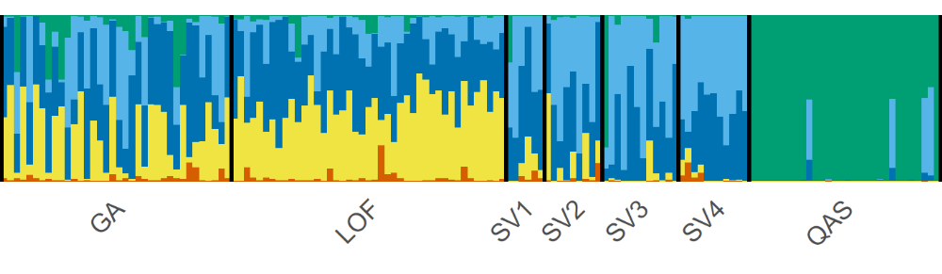
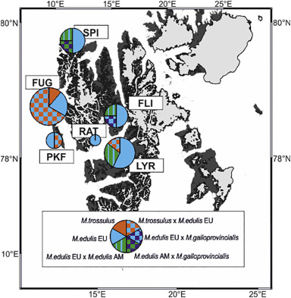
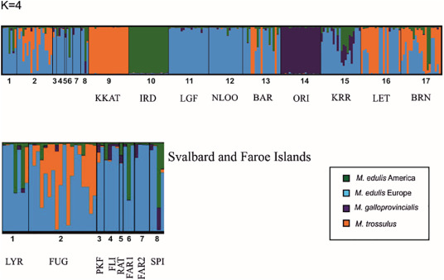

According to Mathiesen et al. (2017), M. edulis, pure M. galloprovincialis and hybrids are present in recently re-established populations on Svalbard.
Reference specimens of M. galloprovincialis originated from the Mediterranean at Oristano (ORI). Additionally, mixed populations of M. edulis / M. trossulus from Barents Sea (BAR), Norway, Bergen (BRN) and Great Britain, Scotland, Loch Etive (LET), and population of M. edulis/M. galloprovincialis from Kerrera (KRR) were used to determining the potential source of mussels on Svalbard (Wenne et al., 2020). Seventy-nine SNPs differentiating Mytilus taxa and potential hybridisation were used (Gardner et al., 2016; Zbawicka et al., 2019, Zbawicka et al., 2018, Zbawicka et al., 2012). Samples were genotyped using the Sequenom MassARRAY iPLEX platform (Gabriel et al., 2009).
Mathiesen et al. (2017) have reported errorneously occurrence of pure M. galloprovincialis in their samples from Svalbard (Kongsfjorden and Adventfjorden) due to methodological reasons (Simon et al., 2019). Despite that, Simon et al. (2019) stated that admixed mussels in Svalbard have lower proportions of Atlantic M. galloprovincialis ancestry than admixed mussels from Norway: Lofoten and Gaseid. According to our data only minor contribution of M. galloprovincialis genes to the genetic composition of Svalbard samples (FLI, SPI) was confirmed, but no M. galloprovincialis as a taxon was observed in this study.
К суммированию генетических данных.
Карта c ME15|16 Brooks, Farmen; точки геномных исследований пинами или как?
Интерпретации генотипов: STRUCTURE, NEWhybrids у Венне; какие критерии? Какие определения «гибридов»? Какие определения amixed? Pure?
Hybrids: ? syn. first generation hybrids (F1). Alternatively, any of mixed ancestry i.e. genes from two or more species
Early generation hybids:
Admixed individuals:
Late generation hybrids:
The contradictions arise, firstly, from differing results in the analysis of the genotypic structure of samples from the same populations—or even the same samples—when different methods are used. Secondly, they stem from varying definitions of 'purebred' and 'hybrids,' where the latter may refer to heterozygotes at single loci, early-generation hybrids (by NewHybrids), or any genotype with a detectable contribution of genes from different species (by Structure).
Chapuis, A. F., Simon, A., Arthur, G., Fraslin, C., Cariolato, E., Mirimin, L., ... & Regan, T. (2026). Patterns of introgression in farmed mussels: A genomic study of Mytilus spp. in northern Scotland and Ireland. Aquaculture, 743643.

